LEGO Wiggle Worm
Name: ________________________
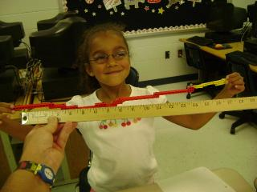
Materials: 1 Yellow Set, Measuring Tape
Objectives: To create a wiggle worm with the highest score.
Essential Questions:
- What is a wiggle worm?
- How do you measure something?
- What is the difference between “extended” and “folded”?

Directions: Today you are going to create a wiggle worm. You want to make it as long as possible when it is extended and as short as possible when it is folded.
Score= Length-Folded Length

Remember: You will measure your wiggle worm extended and you will measure it folded.

Calculations: (Don’t forget Units of Measurement!)
- How long is your wiggle worm when it is EXTENDED? ______________

- How long is your wiggle worm when it is FOLDED? _________________
- Score = Length - Folded Length _______________

- How many SECTIONS does your wiggle worm have? _________________

- How many DOTS do you see on the top of your wiggle worm? __________

- Fold up your wiggle worm. How much does it weigh? _____________

- Take A Picture of Your Wiggle Worm Extended. Paste it here!

